amir iqbal butt – Electrical Site Supervsior
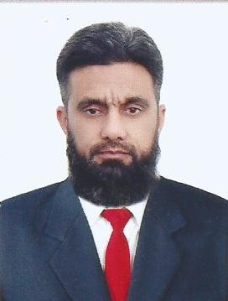  PERSONAL DATA:  Mobile # 059-720-4296  Gender: Male  D.O.B: 24-March-1980  Marital Status: Married  EMAIL:  Aamarbutt390@yahoo.com  RESIDENCE:  Sialkot Pakistan  Driving Ability :  - Valid Pakistani Licence  - Saudi Licence (Expired)  INTERESTS:  - Cricket  LANGUAGES KNOWN:  English, Urdu, Punjabi, Arabic  (Writing, Reading, Speaking) | CAREER OBJECTIVE:  To obtain a growth oriented and challenging position in an intellectually stimulating environment where I can utilize my techniques and skill. Capable of quickly adapting a changing environments and able to work on own initiative or as part of a team.  ACADEMICS & Professional Education  - D.A.E (1999)  PBTE Lahore  - SSC (1996)  BISE Gujranwala  - NEBOSH (2021)  (International General Certificate in Occupational Health and Safety)  - D.I.T (Diploma in Information Technology)  Rabta Institute of Computer Sciences  key skills:  - Honest and hardworking.  - Enthusiastic and Self Motivated  - Good decision making skills.  - Know how about MS office  - High Ethical Values and standards  experience:  - Work as Electric Technician and Generator Operator in Elahi Electric Company Lahore (From 17-10-2000 to 17-03-2002)  - Work as a Line Superintendent in GEPCO (From 2002 to 2006)  AAQ Company K.S.A  - Work as Electrician (From 2006 to 2009)  - Work as Workshop Foreman (From 2009 to 2012)  - Work as Underground Cable (HT, LT) Foreman (From 2012 to 2019)  - Work as Overhead (HT Lines) Foreman (From 2019 to 2021)  - Work as Safety Officer (2021)  REFERENCE:  - Will be provided on demand

Detailed Roles and Responsibilities:
Detailed Responsibilities: -

- Install and maintain road pole lights and lighting systems.
- Provide technical guidance and support as the team installs, maintains, and repairs the SEC electrical system.
- Inspect electrical components, such as circuit breakers.
- Identify electrical problems using a variety of testing devices.
- Repairing, replacing, and upgrading faulty or outdated electrical equipment, fixtures, and including isolating faults for safe removal and replacement.
- Training other electricians and directing them to perform specific tasks.
- Interacts cross-functionally with Field Engineers and other team members.
- Application of all responsibilities regarding the company’s environment, health, safety, security and quality standards.

