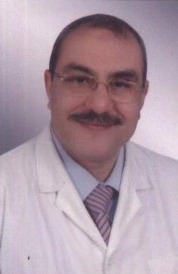**Curriculm Vitae**

**Name** : Ahmed El Badawi Desouki AboEl enean Mohamed

**Address** : Al Fouad polyclinic Jeddah KSA

**Country** : KSA. Jeddah

**Date** **of** **birth** : 18-1-1961

**Marital** **state** : married

**Tel** : 02 6721834

**Mobile** : 0547275835

**E mail** : [aaboelenean@yahoo.com](mailto:aaboelenean@yahoo.com)

[badawi6138@gmail.com](mailto:badawi6138@gmail.com)

***Career Objective***

Medical laboratoty Specialist Senior

***Educational Qulification :***

2005 -2009 Philoshophy degree in Aplied medical Chemistry, Alexandria university

1998-2002 Master degree in Aplied medical Chemistry ,Alexandria university

1985 -1986 diploma in biochemistry, Alexandria university

1979-1983 Bachelor degree in biochemistry ,Alexandria university

***Professional Qualification:***

2012- 2024 Senior lab. Specialist in Al Fouad polyclinic in Jeddah K.S.A

2010 - 2012 Lab . Specialist in Masar ElSeha polyclinic in Tabouk K.S.A.

2005 – 2010 lab consultant in Dr Moh. Naguib laboratory in Egypt Alexandria

2002 - 2005 lab specialist in el Edrissi polyclinicAl Ehsaa in KSA

1995 – 2002 lab specialist in Dr Moh. Naguib laboratory in Egypt Alexandria

1988 – 1995 lab specialist in Al Amal polyclinic Mahayel Asser in kSA

1986 – 1988 lab specialist in Fager el Eslam poly clinic in Egypt Alexandria